**Mars Rover design Team Power train**

**Power board**

The purpose of the main power board is to condition and regulate the flow of power to the subsystem of the rover. For many of the subsystems, the 24V from the battery needs to be reduced. Overvoltage and overcurrent protection mechanisms need to be included with the system to prevent damage to rover components during faults.

**Power distribution overview**

The power system is split up into different busses, each operating at a specified voltage level:

* Main battery bus (24V)
* POE BUS 1 (20V)
* Auxiliary BUS 1 (12V)
* Auxiliary BUS 2 (12V)
* Small Control Auxiliary Bus (5V)
* Control/Telemetry bus (5V)

The main battery bus feeds all other busses as well as the electric motors on the rover. The main battery bus is connected through an electronic breaker to the battery protection system. The electronic breaker implements provide overcurrent protection for the overall power system. In addition, the emergency stop button is wired to this breaker to immediately cut power to the rover systems.

The lower voltage busses are connected through a DC/DC converter to the battery bus. The DC/DC converter both steps the voltage down and acts as additional overcurrent protection.

Overvoltage protection is realized with TVS diodes. Each individual bus has at least one TVS diode to clamp the maximum voltage to a safe level. Sensitive equipment may receive individual overvoltage protection if the responsible team feels that their equipment requires special attention.

The power board is monitored and controlled by a dedicated microcontroller that communicates with the control board of the rover. Currently an Atmega 328P is selected to supervise the power board; however, the communication team needs to confirm that this selection is appropriate. The controller will monitor voltage levels on all busses and control the flow of power through the system as needed.

The individual subsystems of the rover power system are explained in more detail in the following sections.

**DC/DC converter**

The DC/DC converters have to efficiently step down the battery voltage to the desired voltage level. A number of different options were considered including linear regulators and custom-designed power supplies. Linear regulators operate very inefficiently, especially with large voltage differences, therefore they were deemed inadequate. A custom designed buck converter would allow the team the most flexibility, however implementation cost could be high. In addition, extensive prototyping would be required.

A premade step down DC/DC power supply is the best choice to quickly and reliably implement the power system. A variety of step down converters are available, however the most efficient (max. efficiency 96%) and easiest to integrate is the PTN78020 series from Texas Instruments.

The PTN78020 was also used on last year’s power system and performed exceptionally well. The high efficiency paired with the extensive overcurrent and temperature protection features make it a reliable supply. In addition, the PTN78020 can be controlled by a microcontroller for a more intelligent power distribution system. Lastly, the supply is small, requiring little space in the rover.

A schematic of the PTN78020 integration in the rover power system is shown below.

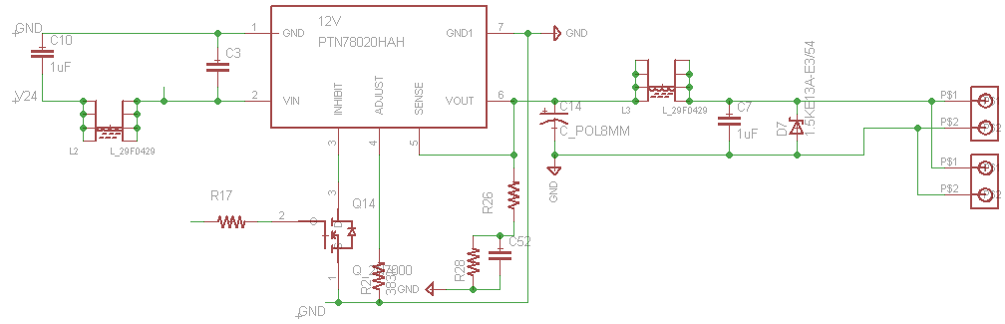

The box in the middle indicates the PTN78020, with a number of additional components added to support the PTN78020. Texas Instruments specifies minimum input and output capacitor sizes for this power converter.

The input was chosen to be a 22µF XR5 ceramic capacitor by TDK. This new TDK multiplayer ceramic capacitor series features a high capacitance (22uF) in a small form factor (1206 package) reducing the overall space requirement of the converter. The XR5 dielectric also allows the capacitor to be used with temperatures up to 85 without significant loss in capacitance.

The output capacitor requirement is realized by one 330µF Aluminum Electrolytic capacitor. This capacitor smoothens out the output voltage and provides a low frequency pole for the buck converter. The output current of the buck converter is continuous, therefore the ripple current capability of the output capacitor does not have to be very large. The Panasonic EEC-FC1V331L was chosen as the output capacitor. The EEC-FC1V331L has a small form factor (8mm diameter), a high current ripple capability (1A) and supports high switching frequencies (up to 100kHz, limits conducted noise).

The converter operates with a variable switching frequency between 650kHz and 1Mhz. This high varying switching frequency produces a lot of broadband noise that can interfere with different rover components through conducted emissions. To reduce the conducted broadband emissions caused by the switching converter a Ferrite bead is added to both the input and output. The Ferrite bead introduces a high impedance at high frequencies to suppress noise. At low frequencies the bead has a low ESR (10mΩ) to minimize the losses of the bead. The impedance of the used Ferrite bead (29F0429-0T0-10) is shown below:

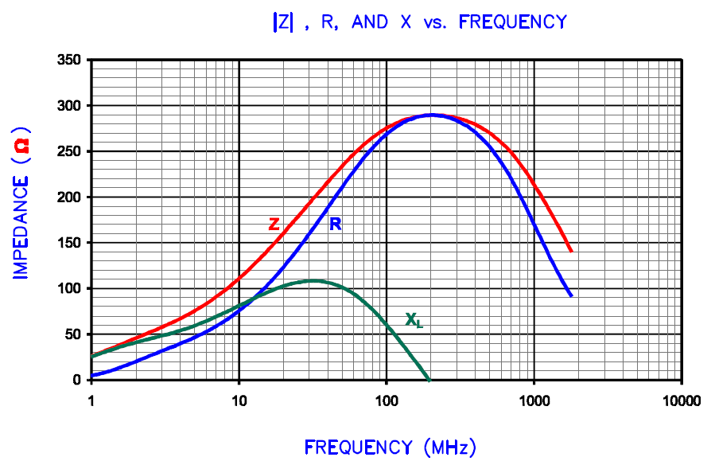

A appropriate TVS diode is added at the output of each converter to provide overvoltage protection. The reverse standoff voltage is selected to be as close as possible to the nominal output voltage of the converter. This insures that the voltage of the bus cannot rise far above the nominal level, while not interfering with the normal operation of the converter. The TVS will effectively limit the voltage below the clamping value:

* 5V reverse standoff (nominal operating voltage) clamps to 7.5V
* 12V reverse standoff; clamps to 18.2V
* 20V reverse standoff, clamps to 33.2V

Typical I-V curve of a TVS diode showing reverse standoff, breakdown and clamping voltage:

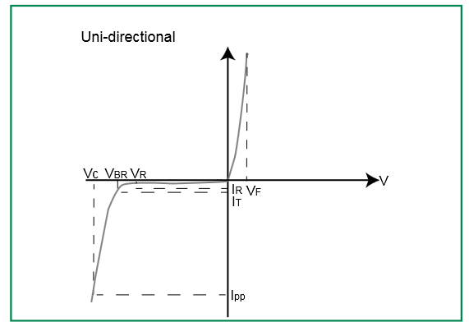

The PTN78020 limits the output current of the converter to 6Amps continuously, regardless of output load conditions. This feature is used to provide overcurrent protection to each bus. If a bus is shorted, the maximum short circuit current will be limited to 6A. The short circuit will cause the bus voltage to collapse. This change in bus voltage is detected by the microcontroller that monitors each bus. If an under-voltage persists the PTN78020 of the associated bus can be turned off by the micro controller by pulling the Inhibit pin to ground. The Inhibit pin is controlled using a 2N7000, which is a small signal N-Channel MOSFET, which can be controlled by the microcontroller.

The PTN78020 also features an build in overtemperature protection. The converter will shut itself off if it gets too hot during operation. It enables itself again, once it has cooled down to a safe operating temperature. Excessive ambient temperatures or operating the converter at the current limit may cause the converter to overheat. The current derating based on the ambient temperature are given below:

**Maximum operating temperature based on current draw**

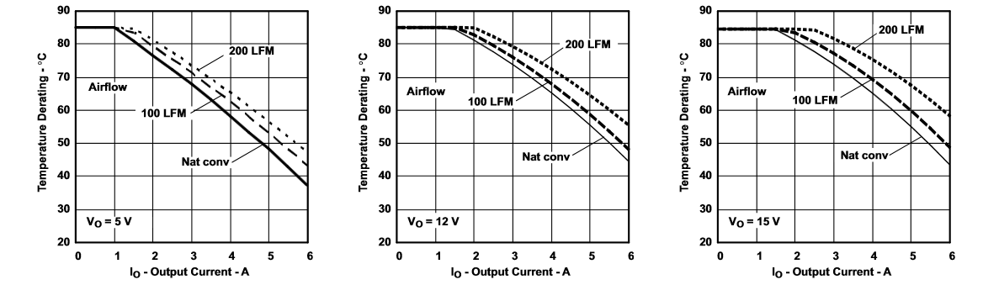

Note: These curves were obtained from the PTN78020 datasheet. They are based on a 10cmx10cm with 2 oz. copper. The actual power board is 15.24cmx24.13cm with 1 oz. copper. The larger area will assist with heat dissipation. 5 boards are sharing the PCB, therefore not all of them should be run at full power continuous without additional heatsinks as this will cause excessive heat accumulation.

**Power Flow Control & Circuit breakers**

The PTN78020 handles overcurrent protection and power flow control for all low voltage busses. However, the main battery, the motors and any additional equipment on the 24V bus need overcurrent protection as well. Traditionally, fuses are used to protect batteries and motor drives; however, they can be bulky, have to be replaced every time they have to protect the circuit, and cannot be externally controlled. Therefore, electronic circuit breakers are a better alternative. They utilize a current sensor to detect unsafe current levels in the system and simply turn off the switch controlling the current flow if an unsafe level is detected. After a certain amount of time has passes the electronic breaker will turn on the switch again to see if the fault has been removed. There is an additional logic input to turn on/off the switch externally. This switch can be used to turn on/off parts of the rover power system when it is not required. A schematic of the setup is shown below.

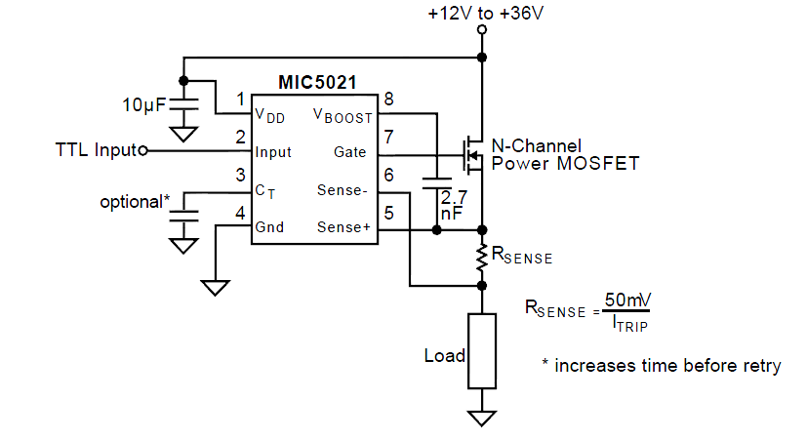

The MIC5021 high side driver is used to realize the circuit breaker logic. The MIC5021 controls the attached N-Channel MOSFET switch directly. An internal charge pump is used to generate the voltage level required to turn on the MOSFET. The charge pump operation allows the MOSFET to be kept on indefinitely.

The internal logic of the MIC5021 turns of the attached MOSFET whenever the voltage sensed across the sense resistor exceeds 50mV or the logic input is set low. The switch is turned on if the logic input is set high as long as there is no abnormal current condition. If the MOSFET is turned off by the current sensor, the switch will be turned back on automatically after some time has passed. The time is depended on the attached capacitance on the pin. A graph showing the overcurrent retry delay based on the attached capacitance is shown below:

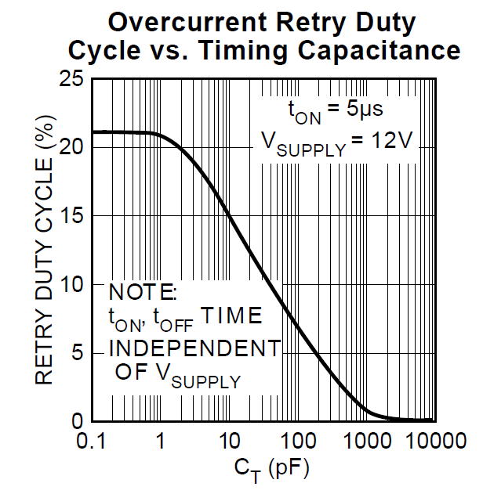

A 1000pF capacitor is used for the timing capacitor as it will create a large time delay before retry operation.

An appropriate N-Chn. MOSFET needs to be selected as well to work with this system. The main battery switch has to handle high continuous current levels without dissipating too much power. A FET with low on state resistance is critical to achieve this. It would be desirable to pick a FET with the smallest possible on state resistance, however the MIC5021 can only support MOSFETs with a input capacitance of less than 10000pF. In the construction of MOSFETs there is generally a tradeoff between on state resistance and the required gate charge (which relates to input capacitance). A large number of MOSFET switches were researched to identify the MOSFET with the lowest on-state resistance which still maintains an input capacitance less than 10000pF. A comprehensive list of low on-state resistance MOSFETs is given below:

|  |  |  |  |  |  |  |
| --- | --- | --- | --- | --- | --- | --- |
| Name | Ron(max) | Cin(pF) | Coss(pF) | Qgate(nC) | Tj | Package |
| IRLB3036GPbF | 3.23mΩ | 11210 | 1430 | 140 | 175 | TO-220 |
| IRLB3034PbF | 2.24mΩ | 10315 | 1980 | 162 | 175 | TO-220 |
| IRFP4004PbF | 2.16mΩ | 8920 | 2360 | 330 | 175 | TO-247 |
| IRFP4368PbF | 2.336mΩ | 19230 | 1670 | 570 | 175 | TO-247 |
| IRFB7430PbF | 1.6mΩ | 14240 | 2130 | 460 | 175 | TO-220 |
| IRFB7434PbF | 2mΩ | 10820 | 1540 | 324 | 175 | TO-220 |
| **IRFB7437PbF** | **2.4mΩ** | **7330** | **1095** | **225** | **175** | **TO-220** |
| AUIRFR8405 | 2.64mΩ | 5171 | 770 | 155 | 175 | TO-220 |
| AUIRF3805 | 4.16mΩ | 7960 | 1260 | 290 | 175 | TO-220 |
| AUIRFB8409 | 1.552mΩ | 14240 | 2130 | 450 | 175 | TO-220 |
| AUIRFS3004 | 2.24mΩ | 9200 | 2020 | 240 | 175 | TO-262 |
| AUIRFB8407 | 2.56mΩ | 7330 | 1095 | 225 | 175 | TO-262 |
| AUIRF2804WL | 2.512mΩ | 7978 | 1693 | 225 | 175 | TO-262WL |
| FDP8443 | 6.1mΩ | 9310 | 800 | 185 | 175 | TO-220 |
| FDP020N06B | 2.64mΩ | 20930 | 4992 | 268 | 175 | TO-220 |
| FDA8440 | 2.82mΩ | 24740 | 2450 | 450 | 175 | TO-3 |
| STP400N4F6 | 2.72mΩ | 20000 | 1740 | 377 | 175 | TO-220 |
| PSMN2R2 | 3.25mΩ | 8423 | 1671 | 130 | 175 | TO-220 |
| PSMN1R5 | 2.6mΩ | 9710 | 2042 | 136 | 175 | TO-220 |
| PSMN2R0 | 5.1mΩ | 13500 | 1640 | 192 | 175 | TO-220 |
| STI360N4F6 | 2.88mΩ | 7930 | 1560 | 340 | 175 | TO-220 |
| IPP020N06N | 2.75mΩ | 9750 | 1800 | 35 | 175 | TO-220 |
| IPP023NE7N3 | 3.25mΩ | 14400 | 3220 | 54 | 175 | TO-220 |
| IXFH400N075T2 | 2.3mΩ | 24000 | 2770 | 420 | 175 | TO-247 |
| AOT240L | 3.9mΩ | 3510 | 1070 | 72 | 125 | TO-220 |
| AOT260L | 3.5mΩ | 14200 | 1770 | 180 | 125 | TO-220 |
| BUK752R3 40E | 4.4mΩ | 8500 | 1450 | 109.2 | 175 | TO-220 |

The IRFB7437PbF from International Rectifier was chosen as the MOSFET for the breaker. It has a low on-state resistance while maintaining a low enough input capacitance. The IRFP4004PbF is another alternative, however its input capacitance is very close to the limit, which can overburden the MIC5021 when the breaker has to operate frequently. Additionally, the large gate capacitance causes the switch to turn on much slower, which puts further stress on the switch.

The IRFB7437PbF was chosen for all electronic breaker circuits. Detailed specifications of the IRFB7437PbF are shown below:

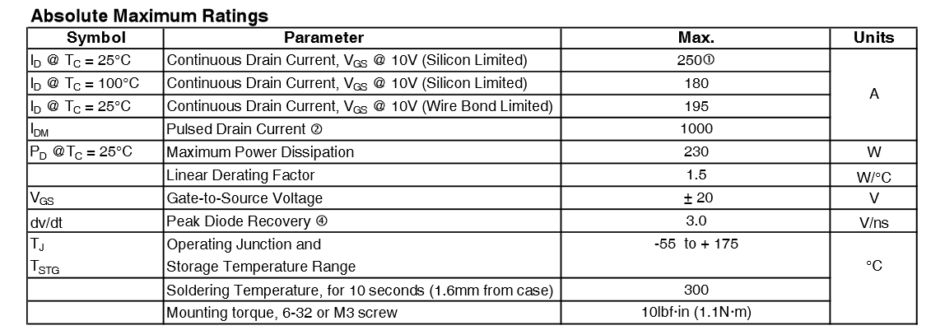

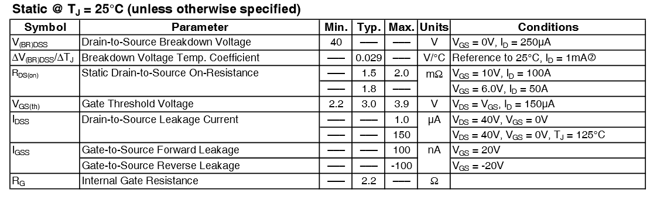

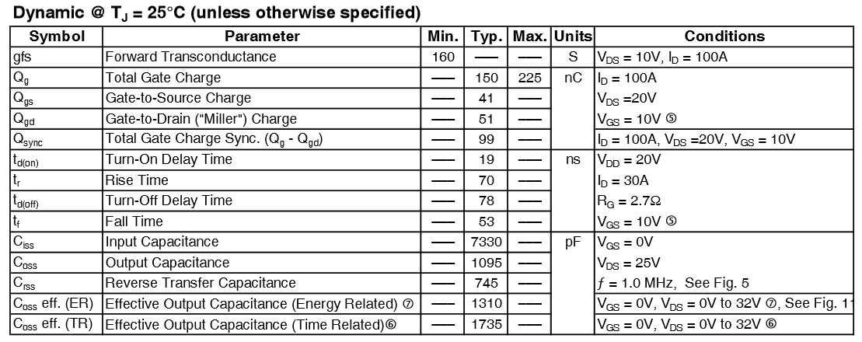

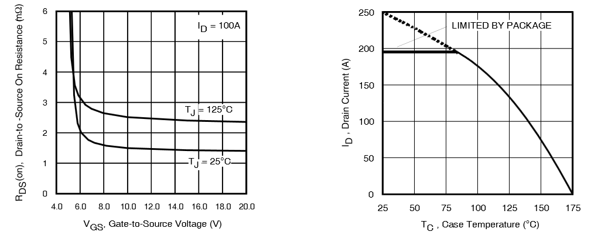

The input capacitance of 7330pF will result an MOSFET turn on time of 1.5µs. This turn on time is considered very slow. However, the circuit breaker does not switch very often, which makes this acceptable. The circuit breaker should not be rapidly switched as this will cause excessive stress on the MOSFET switch.

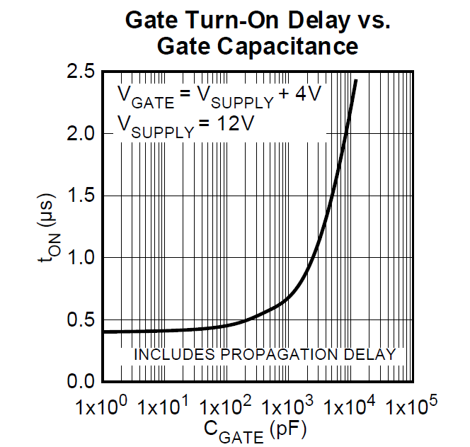

**Board Control**

The power boards is controlled using an Atmega 328P. The Atmega 328P is a 8-bit Microcontroller operating at 16Mhz. The Atmega features 2 high speed PWM outputs, 6 Analog to Digital converters (ADC) and a large number of additional I/O pins to implement additional functions. The Atmega can communicated over UART to other microcontrollers.

All available I/O pins of the Atmega are used to control the circuit breakers or DC/DC converters. The ADCs are used to measure important operating states of the power such as total input current, ambient temperature and bus voltages. An overview of the Pin assignments of the Atmega is shown below:

|  |  |  |  |  |
| --- | --- | --- | --- | --- |
| Pin Name | DIP28 Pin | Arduino Equivalent | Type | Controls/Reads |
| PC6 | 1 | Reset | Input | Resets Atmega 328P |
| PD0(RXD) | 2 | Digital 0 (RX) | Input | Receives serial data |
| PD1(TXD) | 3 | Digital 1 (TX) | Output | Sends serial data |
| PD2 | 4 | Digital 2 (Interrupt 0) | Output | MAIN Switch control signal, disconnects battery**\*\*** |
| PD3 | 5 | Digital 3 (Interrupt 1) | Output | POE converter control/ turns of POE |
| PD4 | 6 | Digital 4 | Output | 12V Aux 2 control signal |
| VCC | 7 | N/A | Input | 5V supply IC |
| GND | 8 | N/A | Output | Ground Connection |
| PB6 | 9 | N/A | Clock | Clock pin for 16Mhz clock |
| PB7 | 10 | N/A | Clock | Clock pin for 16Mhz clock |
| PD5 | 11 | Digital 5 | Output | Motor Controller 4 breaker control signal |
| PD6 | 12 | Digital 6 | Output | Motor Controller 3 breaker control signal |
| PD7 | 13 | Digital 7 | Output | Motor Controller 2 breaker control signal |
| PB0 | 14 | Digital 8 | Output | Motor Controller 1 breaker control signal |
| PB1 | 15 | Digital 9 | Output | Auxiliary 24V breaker control signal |
| PB2 | 16 | Digital 10 | Output | Motor Controller 5 breaker control signal |
| PB3 | 17 | Digital 11 | Output | Motor Controller 6 breaker control signal |
| PB4 | 18 | Digital 12 | Output | 5V bus control signal |
| PB5 | 19 | Digital 13 (LED) | Output | 12V Aux 1 control signal |
| AVCC | 20 | N/A | Input | 5V supply for ADC |
| GND | 22 | N/A | Output | Ground Signal for IC |
| PC0 | 23 | Analog Input 0 | Input | Ambient Temperature |
| PC1 | 24 | Analog Input 1 | Input | 5V BUS voltage |
| PC2 | 26 | Analog Input 2 | Input | 12V Auxiliary BUS 1 voltage |
| PC3 | 26 | Analog Input 3 | Input | 12V Auxiliary BUS 2 voltage |
| PC4 | 27 | Analog Input 4 | Input | Battery Voltage |
| PC5 | 28 | Analog Input 5 | Input | Battery Current |

If the control signal for a Bus or motor drive is low, the corresponding bus will be turned off. A high signal enables (turns on) the corresponding bus.

**\*\* Important Note: PD2/Digital 2 will turn off the entire power supply to the rover! This command cannot be reversed as the motherboard and rover antenna will be powered down. The only way to restart the rover after disabling PD2 is to disconnect the battery from the power board or resetting the Atmega 328P with the reset button. The PD2 should only be used as an emergency remote kill switch!**

**Sensor Readings**

The raw measurements from the ADC can be converted to a meaningful value using the following equations:

* Temperature: .0
* Current:
* Voltage 5V:
* Voltage 12V:
* Voltage 24V:

**Reset**

A reset button is provided on the Printed circuit board to reset the Atmega 328P. It can be used to reset the power board after the remote skill switch was used.

**Communication**

Serial Communication to other parts of the rover is realized through RS485. The LTC490CN is used to convert the unbalanced signal from the Atmega 328P to a differential signal. The characteristic of the transmission line is assumed to be 120Ω. The communication lines are both terminated with a 120Ω resistor to insure impedance matching. The differential signal leaves the board through an RJ45 connector.

**Power board startup procedure**

The power board should enable the power outputs one at a time to insure a clean and glitch free start up. This will also reduce the stress on the main battery & switch resulting from excessive inrush currents. During start up the Atmega needs to check the battery voltage. If the voltage is outside of a save operating region it should halt the execution of the program and wait for the voltage to stabilize. Once the voltage is in a valid operating region, the Atmega can turn on the main power switch controlled by PD2. The battery will now charge up the decoupling capacitors and start to supply the motherboard. After a second delay, the Atmega needs to turn on the POE power to enable the antenna. This will establish communication with the base station. If there is a fault on the POE bus, the 12V Aux 2 bus can be enabled to serve as a backup power supply. After connection is established the remaining systems can be powered up based on commands received by the base station. Only one subsystem should be powered up at any given time. Allow a small time interval (1 second) between turning on subsystem to allow the main bus to stabilize.

**Overview of Microcontroller connections**

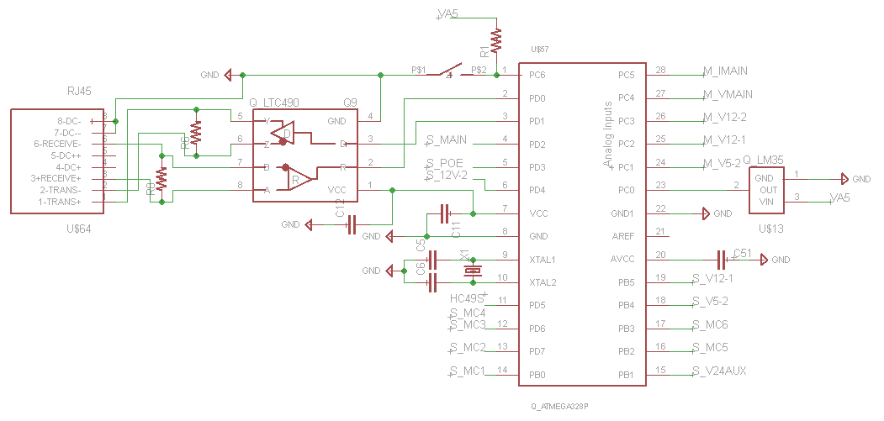

**Power Board Connectors/Bus overview**

|  |  |  |  |  |  |
| --- | --- | --- | --- | --- | --- |
| Name | Bus | Voltage | Max Current | Max Power | Protection |
| J2 – Main Battery | 24V Bus | 24V nominal  Up to 36V | 54.8 A continuous (thermal)  48 A fused | 1.315kW (thermal)  1.15kW fused | Overvoltage  Overcurrent  Undervoltage  Pseudo-Temp |
| 24V Aux Connection | 24V Bus | 24V nominal  Clamped to 34V | 12. 5A fused | 300 Watts continuous | Overvoltage  Overcurrent |
| 24V Motor connections | 24V Bus | 24V nominal  Clamped to 34V | 12.5 fused | 300 Watts continuous | Overvoltage  Overcurrent |
| 5 V Critical | 5V Bus Critical | 5V nominal  Clamped to 7.5V | 6A current limited* | 30Watts continuous* | Overvoltage  Overcurrent  Thermal |
| 5 V Bus | 5V Bus | 5V nominal  Clamped to 7.5V | 6A current limited* | 30Watts continuous* | Overvoltage  Overcurrent  Thermal |
| 12V Bus - 1 | 12V Bus | 12 nominal  Clamped to 18.2V | 6A current limited* | 72 Watts continuous* | Overvoltage  Overcurrent  Thermal |
| 12V Bus - 2 | 12V Bus | 12 nominal  Clamped to 18.2V | 6A current limited* | 72 Watts continuous* | Overvoltage  Overcurrent  Thermal |
| POE Bus | 20V Bus | 20 nominal  Clamped to 33.2V | 6A current limited* | 90 Watts continuous* | Overvoltage  Overcurrent  Thermal |

*This rating is based on favorable thermal conditions (ambient temperatures below 30 degrees Celsius) . Use the derating tables provided below to adjust the maximum current and power draw based on the expected ambient temperature of the power board. The board may be operated above the rated current draw even in high ambient temperatures, however only for short periods of time. The board will turn itself off to prevent itself from overheating.

**Maximum operating temperature based on current draw**



Note: These curves were obtained from the PTN78020 datasheet. They are based on a 10cmx10cm with 2 oz. copper. The actual power board is 15.24cmx24.13cm with 1 oz. copper. The larger area will assist with heat dissipation. 5 boards are sharing the PCB, therefore not all of them should be run at full power continuous without additional heatsinks as this will cause excessive heat accumulation.

**Part List**

The part list for 1 power boards is given below:

|  |  |  |  |
| --- | --- | --- | --- |
|  | **Component** | **Description** | **Quantity** |
| Capacitors | EEU-FC1V331L | CAPACITOR ALUM ELEC, 330UF, 35V, 20%, RADIAL | 5 |
|  | 35PX1000MEFC10X20 | ALUM ELEC, 1000UF, 35V, 20% | 10 |
|  | MC1206N150J201CT | CERAMIC 15PF 200V, C0G, 5%, 1206 | 12 |
|  | C1206C103K5RACTU | CAPACITOR CERAMIC 0.01UF, 50V, X7R, 10%, 1206 | 7 |
|  | CC1206KRX7R9BB104 | CERAMIC, 0.1UF, 50V, X7R, 10%, 1206 | 30 |
|  | MC1206B105K500CT | CERAMIC, 1UF, 50V, X7R, 20%, 1206 | 12 |
|  | C3216X5R1V226M160AC | CERAMIC, 22UF, 35V, X5R, 1206 | 24 |
| ICs | MIC5021YN | IC, MOSFET DRIVER, HIGH SIDE, DIP-8 | 7 |
|  | ATMEGA328P-PN | MCU, 8BIT, AVR, 20MHZ, DIP-28 | 1 |
|  | LTC490CN8#PBF | RS485 TRANSCEIVER FDP 5V | 1 |
|  | ZXCT1109SA-7 | MONITOR, CURRENT, 650KHZ, SOT-23-3 | 1 |
|  | LM35DZ/NOPB | TEMPERATURE SENSOR, 0.4°C, TO-92-3 | 1 |
|  | MC7805ACTG | LDO VOLT REG, 5V, 1A, TO-220 | 1 |
|  | SB530-E3/54 | SCHOTTKY RECTIFIER, 5A 30V DO-201AD | 2 |
|  | IRFB7437PBF | MOSFET, N CH, 40V, 195A, TO-220AB | 7 |
|  | ICTE5-E3/54 | DIODE, TVS, 6.5W, 5V, UNIDIR, DO-201-2 | 1 |
|  | 1.5KE13A-E3/54 | TVS DIODE, 1.5KW, 13V, 1.5KE | 2 |
|  | 1.5KE24CA-E3/73 | TVS-DIODE, 1.5kW, 20.5V, Bidirectional, DO-201 | 2 |
|  | 1.5KE30C-RH | TVS DIODE, 1.5KW, 30V, DO-201AE | 2 |
|  | PTN78020WAH | [DC-DC CONV, LINEAR REG, 1 O/P, 90W, 6A](http://80.93.56.75/pdf/0/3/1/2/6/03126231.pdf) | 2 |
|  | PTN78020HAH | [DC-DC CONV, LINEAR REG, 1 O/P, 90W, 6A](http://80.93.56.75/pdf/0/3/1/2/6/03126231.pdf) | 3 |
|  | 2N7000_D26Z | N CHANNEL MOSFET, 60V, 200mA, TO-92 | 5 |
| Resistors | MCZOT0W400000A50 | RESISTOR, CERAMIC, JUMPER, 0 OHM | 24 |
|  | FC4L110R001JER | [RESISTOR, METAL FOIL, 0.001 OHM, 5W, 5%](http://www.ohmite.com/cat/res_fc4l.pdf) | 1 |
|  | ERJ-M1WTF4M0U | [RESISTOR, THICK FILM, 0.004OHM, 1%, 2512](http://industrial.panasonic.com/www-data/pdf/AOA0000/AOA0000CE7.pdf) | 6 |
|  |  | Misc Resistors |  |
| Inductor | 29F0429-0T0-10 | Ferrite Bead 285 Ohm @ 100Mhz | 12 |
| Crystal | HC49S-16-30-50-70-30-ATF | CRYSTAL, 16MHz, 30pF | 6 |
| Mechanical | 6025DG | HEAT SINK TO-220 | 1 |
|  | 531002B02500G | [HEAT SINK TO-220](http://www.aavid.com/products/standard/531002b02500g) | 1 |
|  | 39970-0102 | TERMINAL BLOCK, PCB, 2POS, 18-6AWG | 1 |
|  | MC24366 | TERMINAL BLOCK EUROSTYLE, 2POS, 26-12AWG | 12 |
|  | 282834-2 | TERMINAL BLOCK, PCB, 2POS, 30-16AWG | 10 |
|  | RJSAE-5080-02 | [CAT5 RJ45 MODULAR JACK, 8POS, 2 PORT](http://www.farnell.com/datasheets/1682699.pdf) | 8 |
|  | MC32857 | SWITCH, TACTILE, SPST-NO, 50mA | 6 |
|  | 2227MC-08-03-18-F1 | CONNECTOR, DIP SOCKET, 8WAY, PC BOARD | 6 |
|  | 1-390262-2 | DIP SOCKET, 28POS, THROUGH HOLE | 6 |
|  |  |  |  |
|  |  |  |  |

**Schematic**

The full schematic and board layout is shown below:

